Prismatic Solar Skin: Energy and Information Surface
White Paper Proof of Concept for a Hybrid Hull Skin that Harvests Power and Carries Structured Data
Document Type | Energy-and-information surface proof-of-concept white paper
Concept Thesis | Extend Prismatic Solar Skin so the same layered hull architecture that harvests, recovers, and conditions power also supports timing, telemetry, pulse traffic, and low-bandwidth waveform transport.
Primary Use | Hybrid energy harvest, internal signaling, telemetry distribution, and emergency pulse routing across the hull
Status | High-level concept architecture draft
Abstract
This proof of concept extends Prismatic Solar Skin from a hybrid energy surface into an energy-and-information surface. The outer hull layer still performs direct solar collection, a thermal-recovery layer still captures part of the infrared and waste heat, and a CPSS-derived conditioning layer still buffers and stabilizes harvested power. The added claim is that the prismatic routing manifold beneath those layers can also carry timing, telemetry, pulse traffic, and low-bandwidth waveform signaling across the hull. In this framing, the skin is not merely a panel. It becomes a distributed utility surface that supports both power and information flow in one managed architecture.
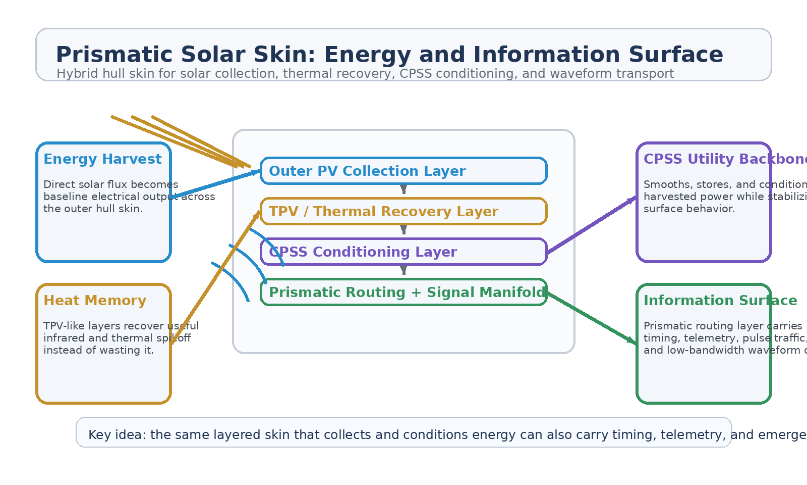
Figure 1. Prismatic Solar Skin extended into a combined energy and information surface.
1. Concept Thesis
The central idea is that a spacecraft hull does not need to choose between being an energy surface and being a signaling surface. Once solar collection, thermal recovery, CPSS conditioning, and prismatic routing are already present, the routing layer can be extended to support structured information flow as well. This does not mean the skin replaces every conventional bus or communications system. It means the same distributed architecture that already moves conditioned energy can also carry timing, telemetry, and low-bandwidth control traffic.
In that sense the skin becomes a utility layer rather than a mere panel array.
2. Layered Architecture
Layer | Subsystem | Primary Function | Information Role
L1 | Outer PV Collector | Captures direct solar flux for primary electrical harvest. | No primary data role
L2 | TPV / Thermal Layer | Recovers infrared and waste heat to improve total energy yield. | Supports thermal state sensing
L3 | CPSS Conditioning Layer | Buffers, smooths, stores, and stabilizes variable incoming energy. | Stabilizes utility behavior for signaling support
L4 | Prismatic Routing Manifold | Distributes conditioned power through a managed hull pathway. | Carries timing, pulse traffic, telemetry, and low-bandwidth waveform signals
L5 | Terminal / Relay Interface | Feeds ship systems, sectors, and relay nodes. | Interprets and uses transported information

2.1 Solar and Thermal Roles Stay Intact
The skin still begins as a real energy surface. The outer collector captures light and the inner TPV-like layer recovers part of the heat burden. This extension does not replace photovoltaic physics with a signaling claim. Instead, it adds an information layer beneath a still-credible energy architecture.
2.2 CPSS as the Surface Utility Backbone
CPSS remains the conditioning and storage backbone. Its role is to smooth intermittent output, absorb transient mismatch, and maintain a more stable utility environment across the hull. That stability is valuable not only for power quality but also for timing and signal support, because a disciplined energy surface is a better host for structured waveform traffic than a noisy one.
2.3 Prismatic Routing as Signal Manifold
The prismatic routing layer is the real extension point. In the original solar-skin concept it was already the routing manifold behind the energy surface. Here it is reinterpreted as a dual-use manifold: one that moves conditioned energy while also carrying timing references, telemetry, pulse signals, and other low-bandwidth waveform traffic across the hull.
3. Why the Data Role Is Coherent
The strongest data claim is not that the hull becomes a replacement for every high-speed internal network. It is that the same distributed surface can support a useful class of structured internal information flows.
• Hull-wide timing synchronization.
• Sector telemetry and state handoff between distributed systems.
• Emergency pulse traffic or SOS-style structured signaling.
• Low-bandwidth control and alert propagation across large surfaces.
• Degraded-mode communications support when primary systems are damaged.
4. Mission Roles
• Combined hull surface for energy harvest and distributed utility signaling.
• Low-bandwidth shipwide telemetry and alert propagation layer.
• Emergency pulse path for damaged or power-stressed vessels.
• Support surface for internal relay meshes and sectorized system coordination.
• Distributed timing spine for large hull sections, habitats, or orbital structures.
5. Advantages Over a Power-Only Skin
• Uses the same layered hull architecture for both power and structured data roles.
• Reduces dependence on separate dedicated signaling surfaces for simple timing and telemetry tasks.
• Improves degraded-mode survivability when primary buses or relay paths are compromised.
• Lets a large vessel treat the hull as a living utility surface instead of a passive collector.
6. Boundaries and Realism
This concept is strongest as an internal or controlled-environment infrastructure layer. It should not be oversold as a universal external communications replacement or as the only high-speed network a vessel will ever need. Its more realistic role is support traffic: timing, telemetry, pulse signaling, and low-bandwidth control layered on top of a hybrid energy skin.
• Best suited to internal signaling, telemetry, timing, and emergency pulse traffic.
• More credible as a support manifold than as a sole high-throughput data backbone.
• Depends on the prismatic layer and interfaces doing the interpretation; the outer collector is still primarily an energy surface.
• Most coherent on large ships or stations where distributed hull utility layers already make sense.
7. Proof-of-Concept Build Path
Phase | Goal | Bench / Program Activity | Success Signal
P1 | Energy skin baseline | Validate hybrid collection, thermal recovery, and CPSS conditioning on a layered mock surface. | Stable energy behavior
P2 | Signal manifold demo | Inject timing or low-bandwidth waveform traffic into the prismatic routing layer. | Repeatable surface transport
P3 | Dual-use stability test | Run power conditioning and signal transport simultaneously under changing input conditions. | No collapse under mixed use
P4 | Sector relay test | Use the surface to hand off telemetry between multiple load or control zones. | Clean state transfer
P5 | Degraded-mode scenario | Test whether structured pulse traffic survives partial surface damage or uneven illumination. | Useful emergency resilience

8. Conclusion
Prismatic Solar Skin: Energy and Information Surface extends the original skin concept in the most coherent direction: not by forcing the collector to do more impossible work, but by letting the already-present routing layer carry additional utility roles. The hull still collects light, remembers heat, conditions power, and now also carries structured information where that helps the ship.
As a white paper PoC, the concept is best understood as a dual-use utility skin: a surface that harvests energy while also supporting timing, telemetry, and emergency waveform traffic across the vessel.
Working one-line doctrine: Let the skin do double duty: harvest energy at the face, and carry timing, telemetry, and pulse traffic through the manifold beneath it.

